XBRL FRANCE – Comments, questions and suggestions on the ESEF Reporting Manual
Update July 2025

Reference | 2024 Update | Comment/question
Guidance 1.2.1 | No | In the third paragraph, the citation of Annex IV.3 of the RTS on ESEF appears to be inaccurate. The correct reference should likely be to point 3 of the RTS (2018/815) instead.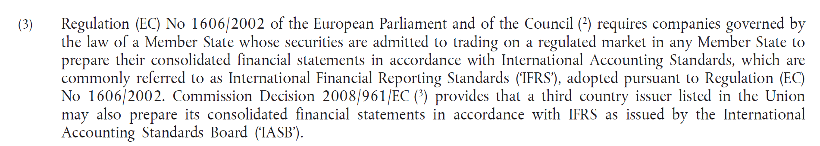
Guidance 1.2.2 | Yes | The example about PPE and Right of use Assets is now outdated.  The last addition is also making the guidance in 1.2.2 more confusing, as it appears to contradict the initial guidance:  - In the first paragraph, it is stated that issuers “should” define an extension taxonomy element that matches a forthcoming taxonomy element, which seems to be required even when not essential for overall usability of the ESEF file  - In the added paragraph, it is stated that the definition of such an extension is “voluntary” and in no way “mandated” (not even recommended)  It would be helpful to clearly articulate the purpose of guidance 1.2.2 (presumably to ensure that all issuers apply the latest concepts added to the IFRS taxonomy, regardless of the ESEF taxonomy they employ, thereby facilitating comparability), and to define its status (must/should/recommended/other) with greater precision. It would be even be better to clarify the point in the RTS.
Guidance 1.2.2 | No | It appears that the reference in the final paragraph to Annex III.1 of the RTS on ESEF may be incorrect. It should likely refer to Annex II.1 of the RTS instead.  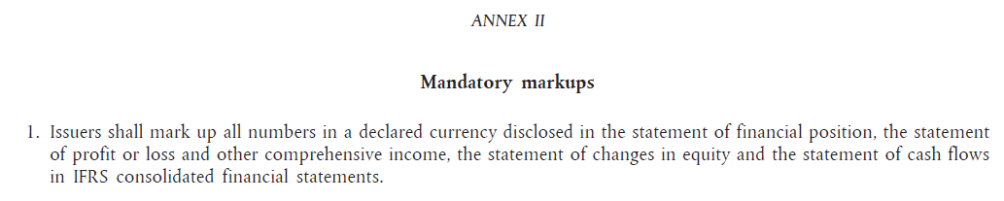
Guidance 2.2.5 | Yes | The new guidance on tagging nil values in the statement of changes of equity does not really help  What would be helpful would be to provide guidance as to exactly which nil values should be tagged in a statement of changes in equity.  e.g. if the line “Issue of equity” is empty in the following example, which data should be tagged as zero?  - All of them (presumably no, as some intersections eg IssueOfEquity/AOCI are unlikely)  - All of the intersections that would be generally expected to be filled in should there be an issue of equity during the period (eg Issued Capital, SharePremium, EquityAttributableToParent, Equity);  - The totals (EquityAttributableToParent and Equity), as having a zero for totals is clear enough that there is no issue of equity during the period;  The new guidance on tagging nil values in the statement of changes in equity lacks clarity. Clear instruction is needed on exactly which nil values should be tagged in the statement.  For example, if the line “Issue of equity” is empty in the following case, which data points should be tagged as zero?  - All of them (presumably not, as certain intersections, such as IssueOfEquity/AOCI, are implausible)  - All intersections that would typically be expected to contain data if an issue of equity had occurred during the period (e.g. Issued Capital, Share Premium, Equity Attributable to Parent, Equity)  - The totals (Equity Attributable to Parent and Equity), as tagging these with zero clearly communicates that no issue of equity took place during the period  The last option appears as the most practical for a complete information without creating more burden.
Guidance 2.2.7 | Yes | Why should be the escape attribute always be set to false for “string” items? Some of them (eg ExplanationOfAssumptionAboutFutureWithSignificantRiskOfResultingInMaterial  Adjustments) may encompass large narrative content. We propose to review their type in the taxonomy. As there is some confusion, it would be better to use a “true” value systematically.  The ERM should also explicitly states that string items should tag only a few words or unformatted sentences.
Guidance 3.4.8 | Yes | The guidance concerning cross-period and cross-dimension calculations has been relocated from section 3.4.1 to the 3.4.8 section and substantially revised, yet the change is neither explained in the introduction nor reflected in the summary table of updates.  This revision to the guidance is rather perplexing.  Previously, the reporting manual included clear direction on documenting cross-period calculations for both the statement of changes in equity and the statement of cash flows, using an abstract, a start-period element, a change element, and an end-period element. That guidance has now been removed for the cash flow statement and replaced with a single example that is applicable only under limited circumstances  This raises two issues:  - How is the CFS example intended to support semi-automatic calculations in situations where the increase (decrease) in cash and cash equivalents is presented before the effects of exchange rate changes, or where other components are included in the reconciliation of cash balances (e.g. changes in the fair value of cash and cash equivalents at FVOCI, or impacts from subsidiaries classified as held for sale during the period)?  - What approach should be taken in cases where issuers have followed the previous guidance in the reporting manual (specifically by creating an abstract in the cash flow statement and subtly adjusting the presentation linkbase to comply with section 3.4.1)? It remains to be determined whether this structure is still acceptable, particularly by analogy with the principle applied in the statement of changes in equity, and given the lack of a viable alternative to enable semi-automatic calculations, except in the basic case shown in the new CFS example (see point 1).  It’s worth recalling that there are still frequent errors in XBRL files, such as signage, balance, date, or scaling issues. These are easily detectable when automatic or semi-automatic calculations are employed. Such calculations therefore play a crucial role in safeguarding data quality.  Furthermore, although the example from the previous reporting manual has been deleted, this removal is only partial. The paragraph below remains in the current version but no longer aligns with the updated guidance:  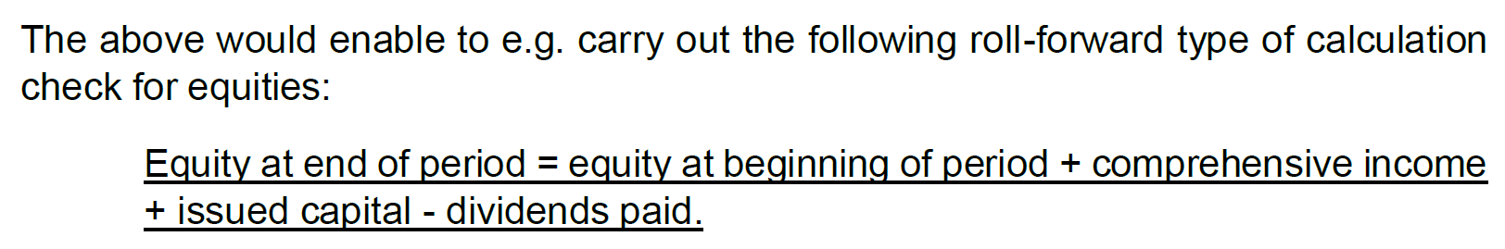  In general, we prefer ESMA to give clear practical/generic rules in the ERM, than examples that are subjects to much interpretation.
Guidance 3.4.8 | No | The description of calculations does not seem correct for items having no balance attribute.  The sentence is as follows: “The plus sign is used in case a line item has no balance attribute (eg cash flows from (used in) operating activities)”.  This holds true only when a nil balance corresponds to a debit in the cash flow statement or a credit in the statement of changes in equity. If the nil balance reflects a credit in the cash flow statement or a debit in the statement of equity, a minus sign must be applied to ensure the calculation is correct.
Guidance 1.3.3 | No | It would be helpful to provide clarification regarding the use of mandatory tags, particularly whether additional tags are required when one has already been applied. For example, it should be clarified whether, in cases where an entity does not separately disclose its principal place of business in the report, because it is identical to the registered office, the tag PrincipalPlaceOfBusiness is not expected to be used (which may be preferable to ensure completeness without adding unnecessary workload), or conversely, whether the registered office address should also be tagged with PrincipalPlaceOfBusiness.  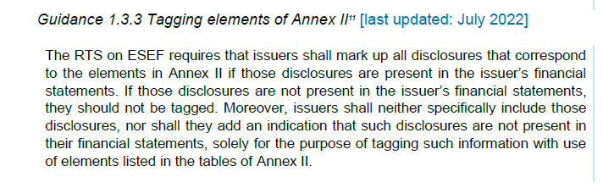
NEW | No | Considering the possibility of applying IFRS 18 in the FY2025 financial statements, it would be advisable to propose the use of the three macro-tags listed below.  - Disclosure of specified expenses by nature [text block]  - Disclosure of management-defined performance measures [text block]  - Disclosure of reconciliation between restated amounts presented applying IFRS 18 and amounts previously presented applying IAS 1 [text block]  The most appropriate approach would however be to include them in the list of mandatory tags (where a corresponding disclosure exists in the report) under the RTS 2025, for early adopters of IFRS 18.  The RTS should then specify that early adopters of IFRS 18 are required to anticipate the 2025 taxonomy (using the correct entry point) and may not continue to apply the 2024 taxonomy.
NEW | No | The tagging of significant events often leads to debate, particularly when it involves mandating the use of a specific concept for each event presented in this commonly observed section of financial reports.  In the same way that the section dealing with post-closing events has its own concept (DisclosureOfEventsAfterReportingPeriodExplanatory), why wouldn’t the RTS / ESMA propose to create a dedicated concept such as DisclosureOfMainEventsDuringReportingPeriodExplanatory?  At present, we apply an overlay tag using a concept that is not included in the list of mandatory concepts (DisclosureOfAdditionalInformationExplanatory).
Guidance 3.4.1 | Yes | The use of Calc 1.1 should be clearly made mandatory with the 2024 taxonomy. Guidance 3.4.1 mix “encourages” and “must”.
NEW | No | The RTS, or otherwise the ERM, should specify the technical standard and validation (conformance suite, etc) to be used, and their application date.
Guidance 2.5.1 | No | “Preparers shall not embed images carrying financial information in ESEF report. Images can only be used for content such as branding information, graphical layout, photographs, etc.”  The rule about inclusion of financial information in image should clarify if it applies to images in the financial report only, or in the whole document. We presently audit the financial report and do not check the rule across the whole document.  The rule should however consider the Commission Implementation Regulation published about ESAP, which doesn’t allow any text embedded in an image in an non-extractable way (in both ESEF and PDF documents), starting in 2026.  We also consider essential to accept that, when the information is given in an image and repeated as raw/tagged text, it is accepted to keep the image as the information may be used.

